
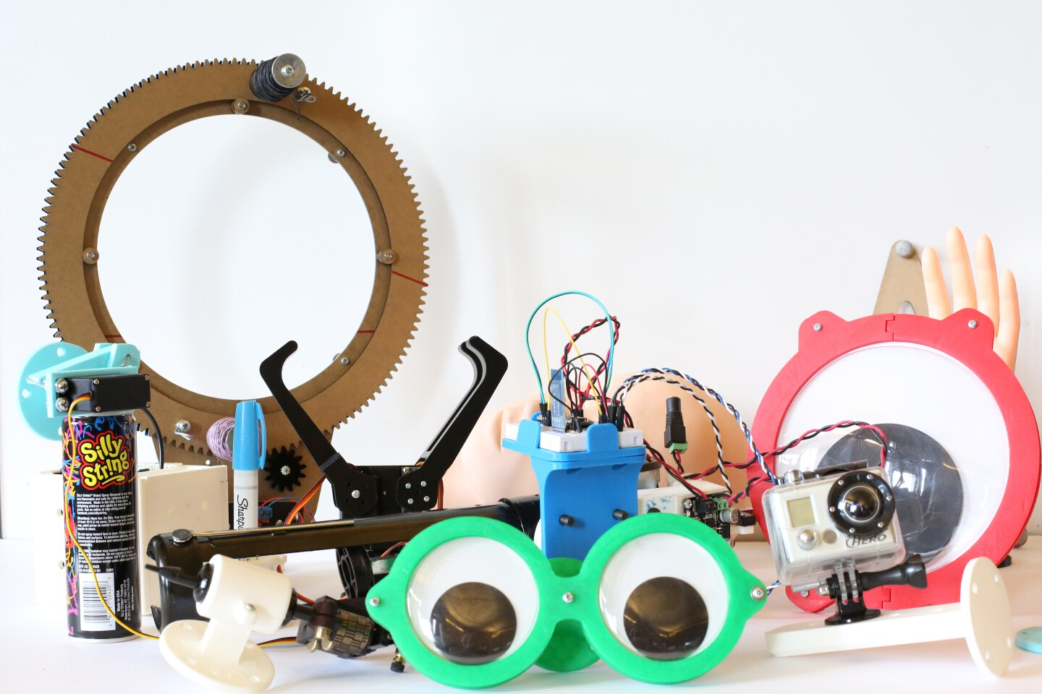


TABLE OF CONTENTS

Introduction:
Synopsis ...........................................3
General Notes ..................................4

Universal Mounts:
Rod Adapter ...................................
Camera Mount ........................................

Electronics Platforms:
Breadboard Mount ..........................
Enclosed Arduino Cube .............................

Googly Eyes:
Googly Eye Double Mount .....................
Googly Eye Single Mount ....................

Tool Adapters:
Ryobi Caulk Gun Adapter ....................
Silly String Adapter .....................
Tattoo Adapter ...........................

Custom Hardware:
Threading Machine ......................
Gripper Mount .........................
CV Effector ..........................

Body Parts:
Finger Mount .......................
Hand Mount ........................
Head Mount .......................

Synopsis
During the Spring of 2016, the Frank-Ratchye STUDIO for Creative Inquiry at Carnegie Mellon University acquired an advanced UR5 robotic arm for use in experimental arts and technology research. A small team of artists and engineers joined forces and formed SCI-RAT (STUDIO for Creative Inquiry Robotic Arm Team) to explore a variety of interesting applications not typically associated with industrial robotic arms.

The people on the team were Madeline Gannon, Dan Moore, Epic Jefferson, Benjamin Snell, Golan Levin, Tom Hughes, and John Choi.
The last person on this list was responsible for creating a variety of low-cost, 3D-printable end effectors for the robot arm. This document, authored by John Choi, contains detailed notes on every adapter created over the course of the 2016 Spring semester.
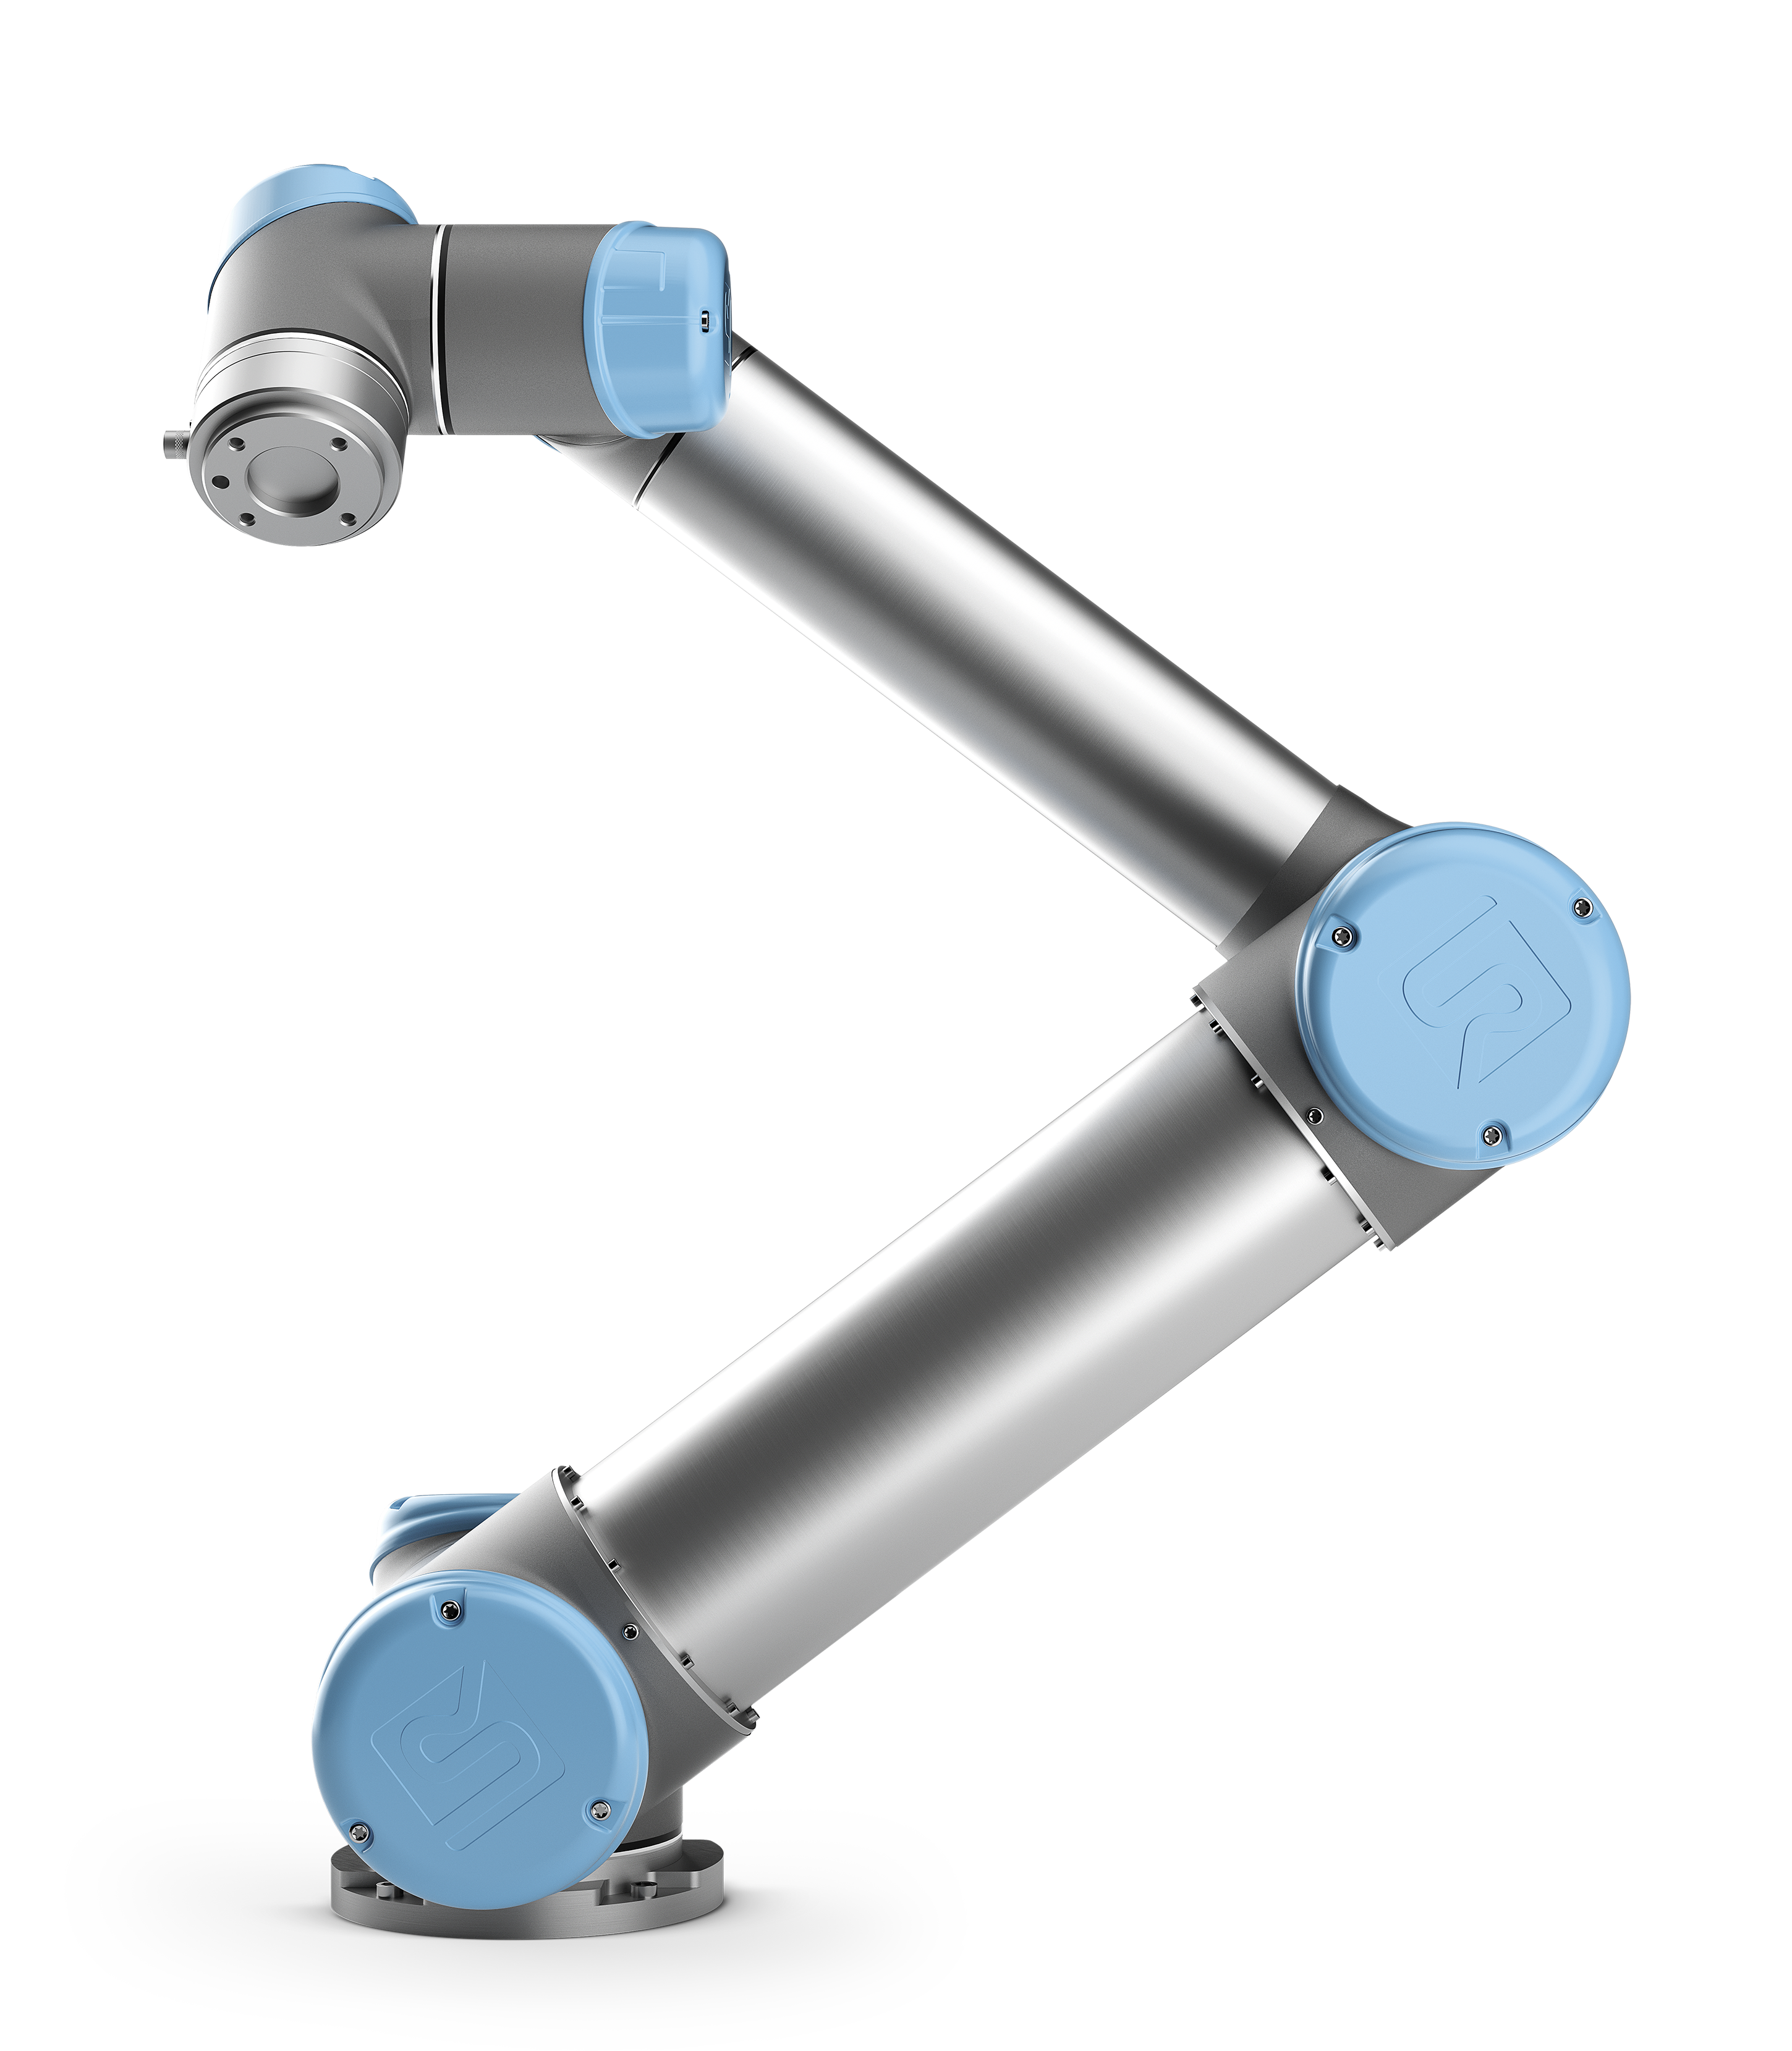UR5 robot arm by Universal Robots.
General Notes
All files are available for download on Github in this link:

The following files are included for every adapter:
[.3dm] The original CAD files made in Rhino.
[.stl] Compatible with various 3D printing sofware.
[.x3g] Machine instructions for Makerbot Replicator 2.

All files are licensed under the CC BY-SA License:
https://creativecommons.org/licenses/by-sa/2.0/

All 3d printed attachments use M6x12 size screws to connect to the front plate of the robot. If attachments are stacked (for example, Gripper with Breadboard Adapter), M6x20 size screws should be used instead. Note that some attachments have multiple components to be assembled, separated due to limitations of 3D printing technology. For these parts, SAE 4-40 size screws and nuts should be used to fasten components together.

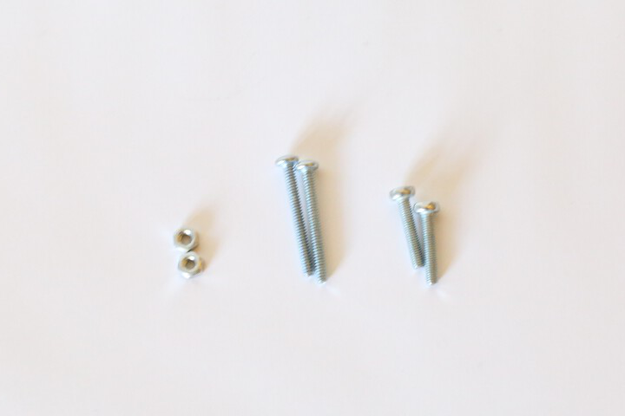Various 4-40 size nuts and screws.
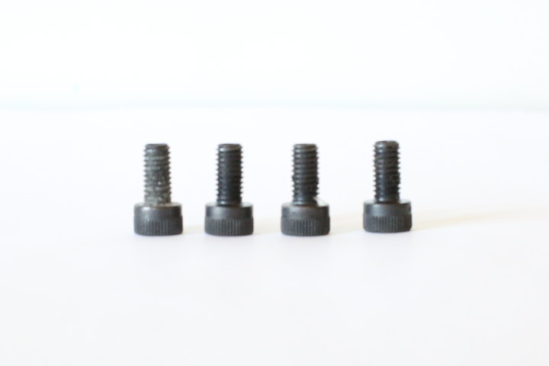Metric M6x12 socket head cap screws.

Rod Adapter
This attachment is designed to connect to any rod-shaped object less than 15 millimeters in diameter. This includes pens, pencils, markers, spoons, laser pointers and more. Rods can be attached either vertically or horizontally, held in place by a set screw. Other objects can be strapped to the rod adapter with cable ties.
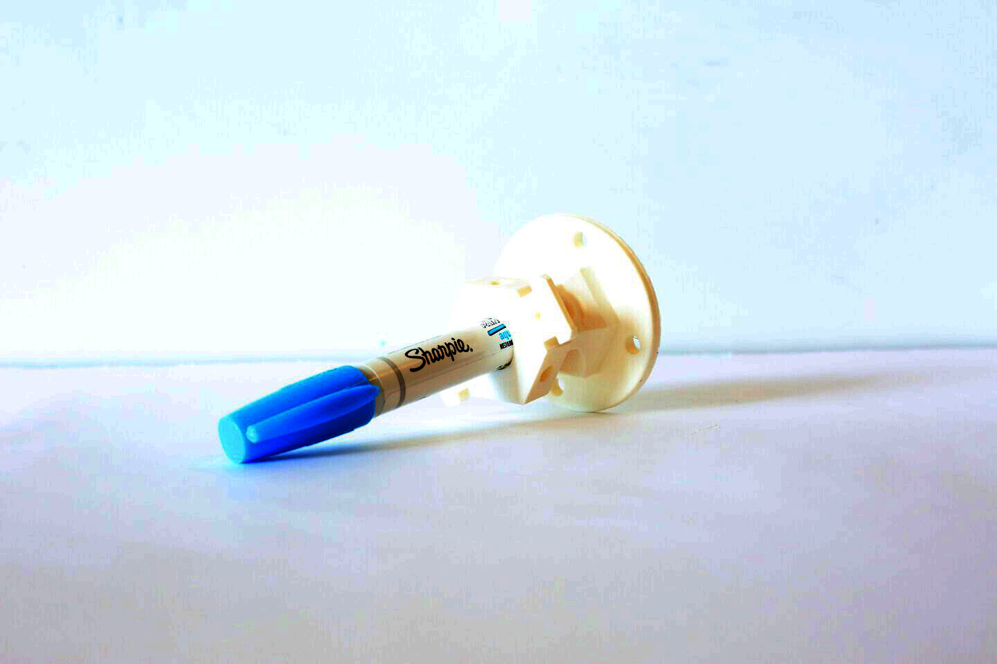Blue permanent marker attached vertically to rod adapter.
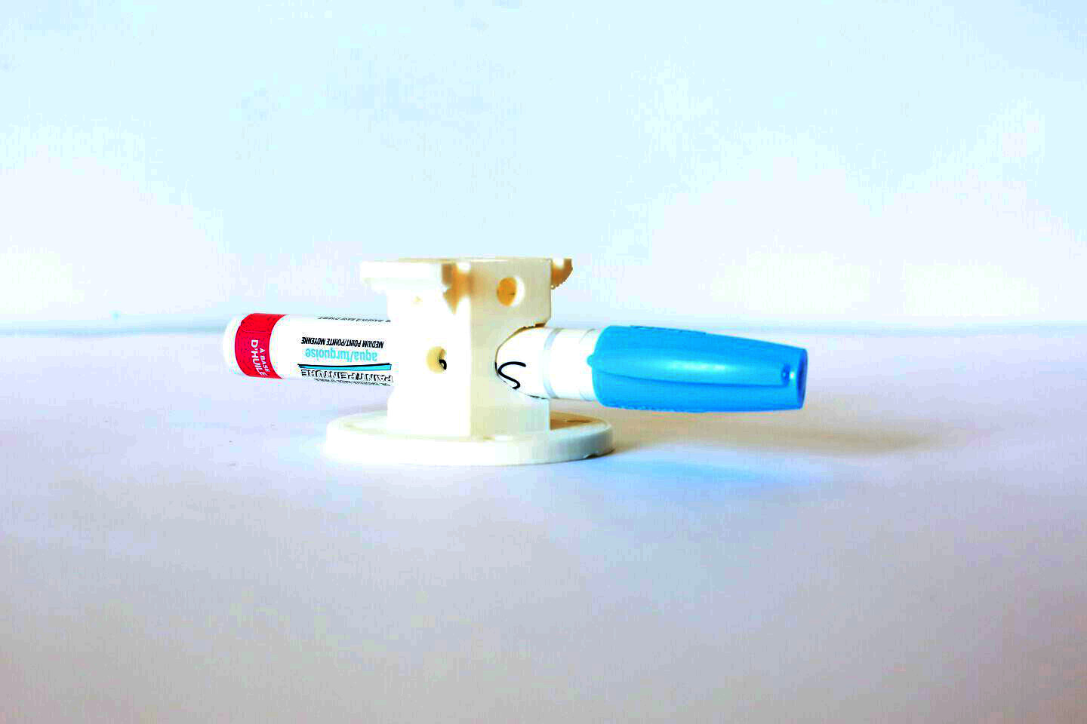Blue permanent marker attached horizontally to rod adapter.
Camera Mount
This attachment is designed to adapt to any device that can be mounted on a standard tripod (diameter 1/4" with 16 threads). There are 4 slots on the camera mount for various device sizes. Example devices that can be mounted are HERO cameras, camcorders, microphones, laser rangefinders and more.
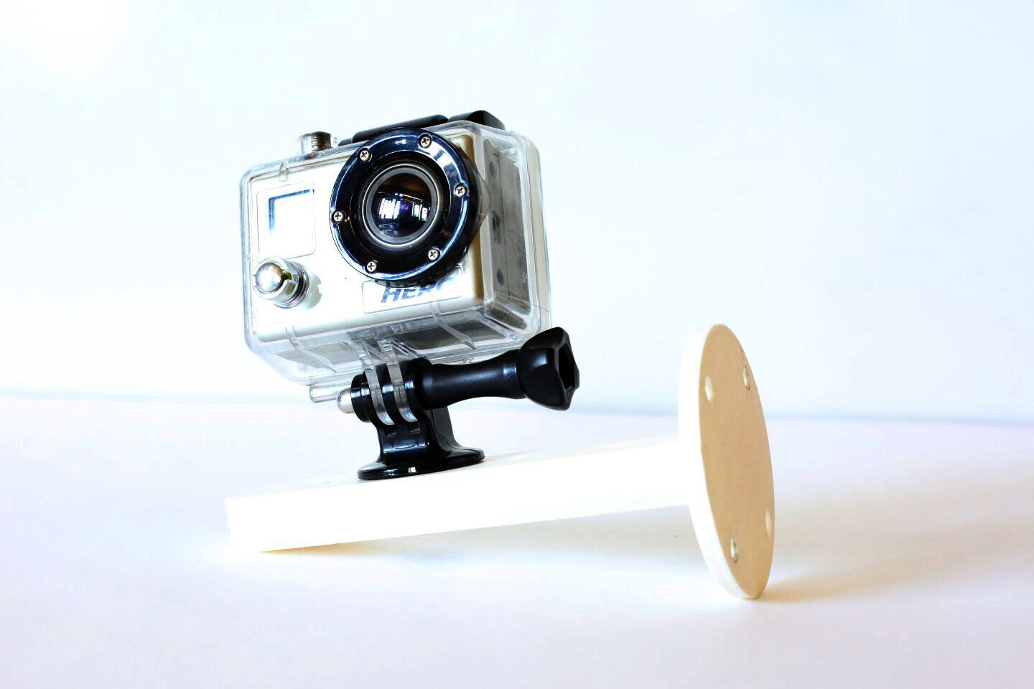HERO camera attached to camera mount (front).
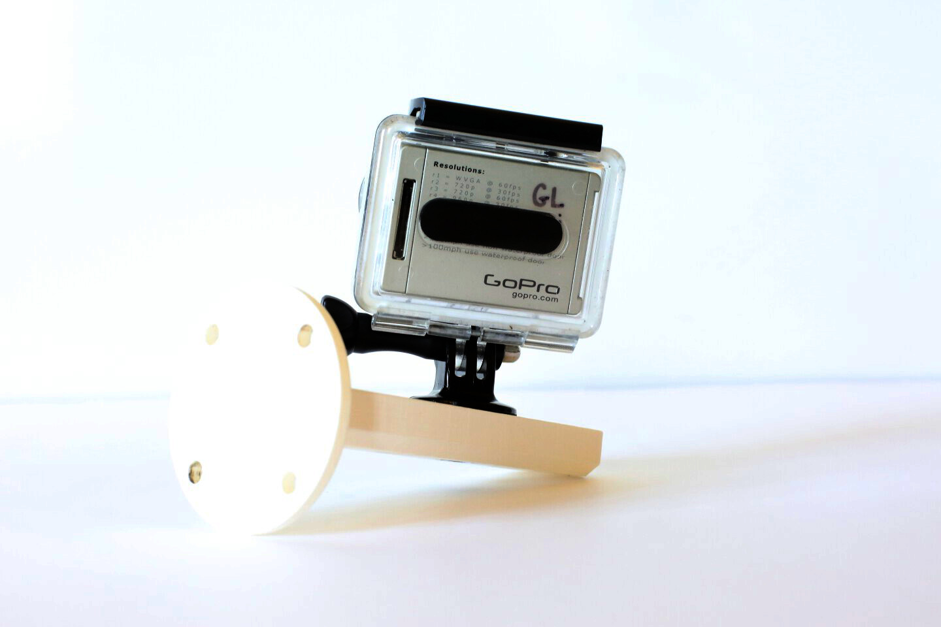HERO camera attached to camera mount (back).
Breadboard Mount
This is a standard attachment that mounts to a full-size breadboard (5.5 cm x 17 cm) onto the end of the UR5. This attachment allows one to prototype basic electronics with the robot and attach a variety of custom sensors and actuators. Due to the impermanent nature of solderless breadboard connections, pins may fall out with enough shock or vibration, therefore it is advised to move the robot slowly while using this attachment.
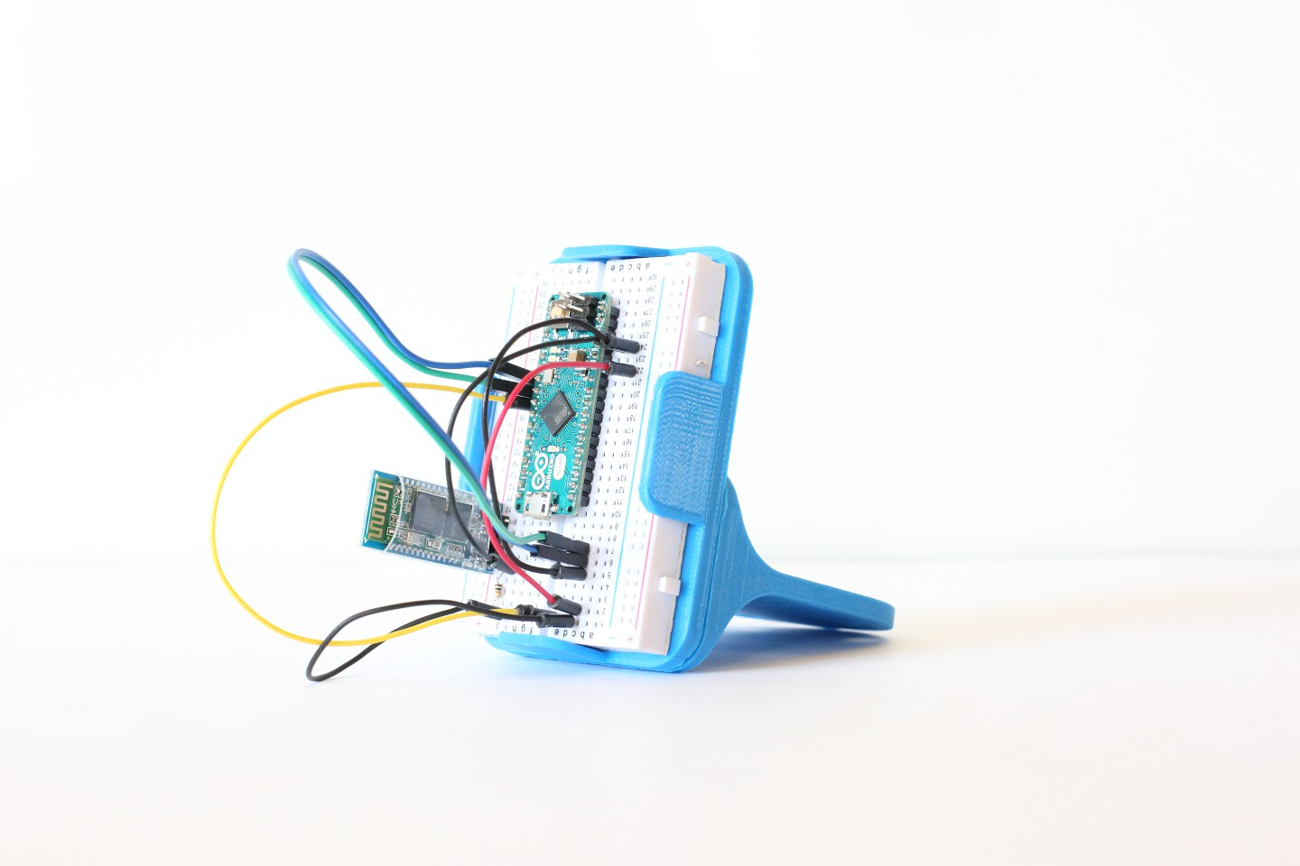Breadboard mount with Arduino Micro attached.
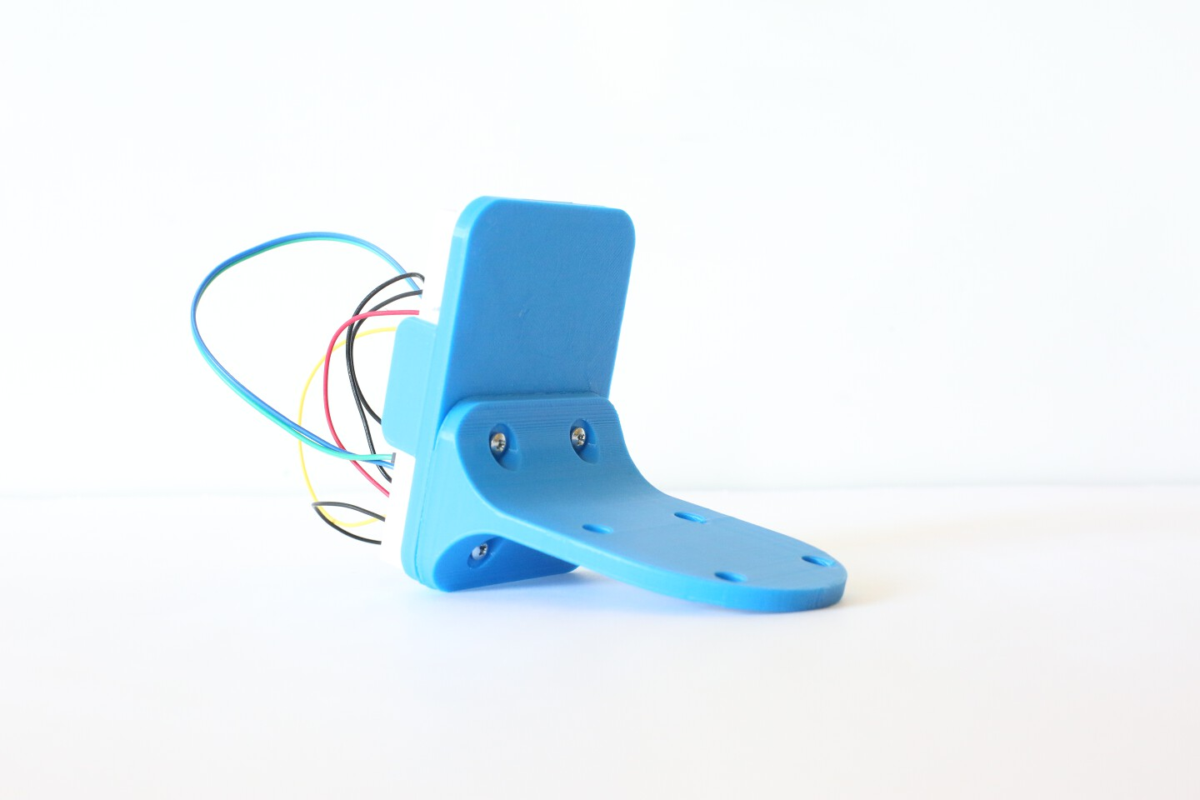The breadboard mount has 2 pieces. Four screws fasten them together.

Enclosed Arduino Cube
For projects that need more protection than what the open-ended Breadboad mount offers, the Enclosed Arduino Cube is recommended as an alternative. This attachment is fairly complex and there are many things to consider while using it on the UR5, listed below:

- An Arduino UNO sits on the left face.
- USB or an HC-06 bluetooth module is used for communication.
- A 6,9, or 12 volt battery pack can be placed on the right.
- On the front is a standard 5.5 cm x 17 cm breadboard.
- The Arduino Mount has three screws on the left face.
- When the left three screws are removed, it folds open.
- When closed, there is one open side to allow wires to go out.
- Four of the five sides can connect to another UR5 attachment.
- The attachment must be open to attach/remove to the UR5.
- Maximum supported weight is roughly 1000g (2 water bottles).

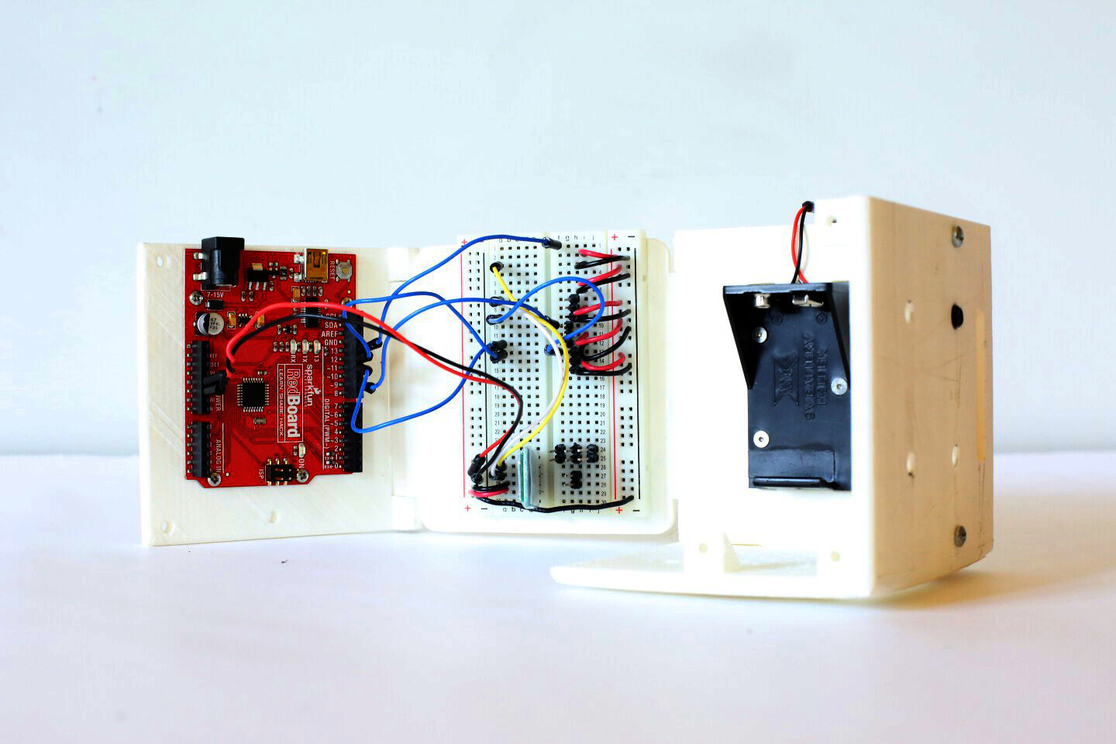Attachment fully open with Arduino and breadboard fully visible.
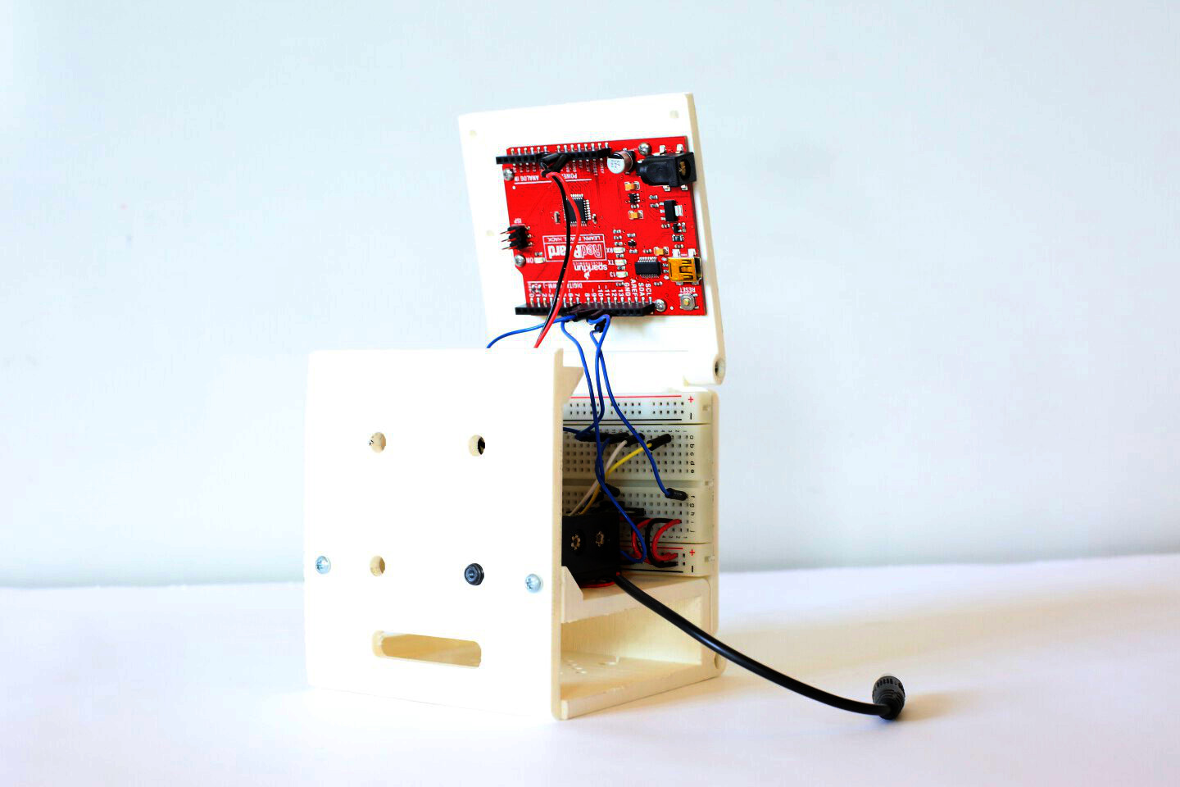Arduino Cube with top open.
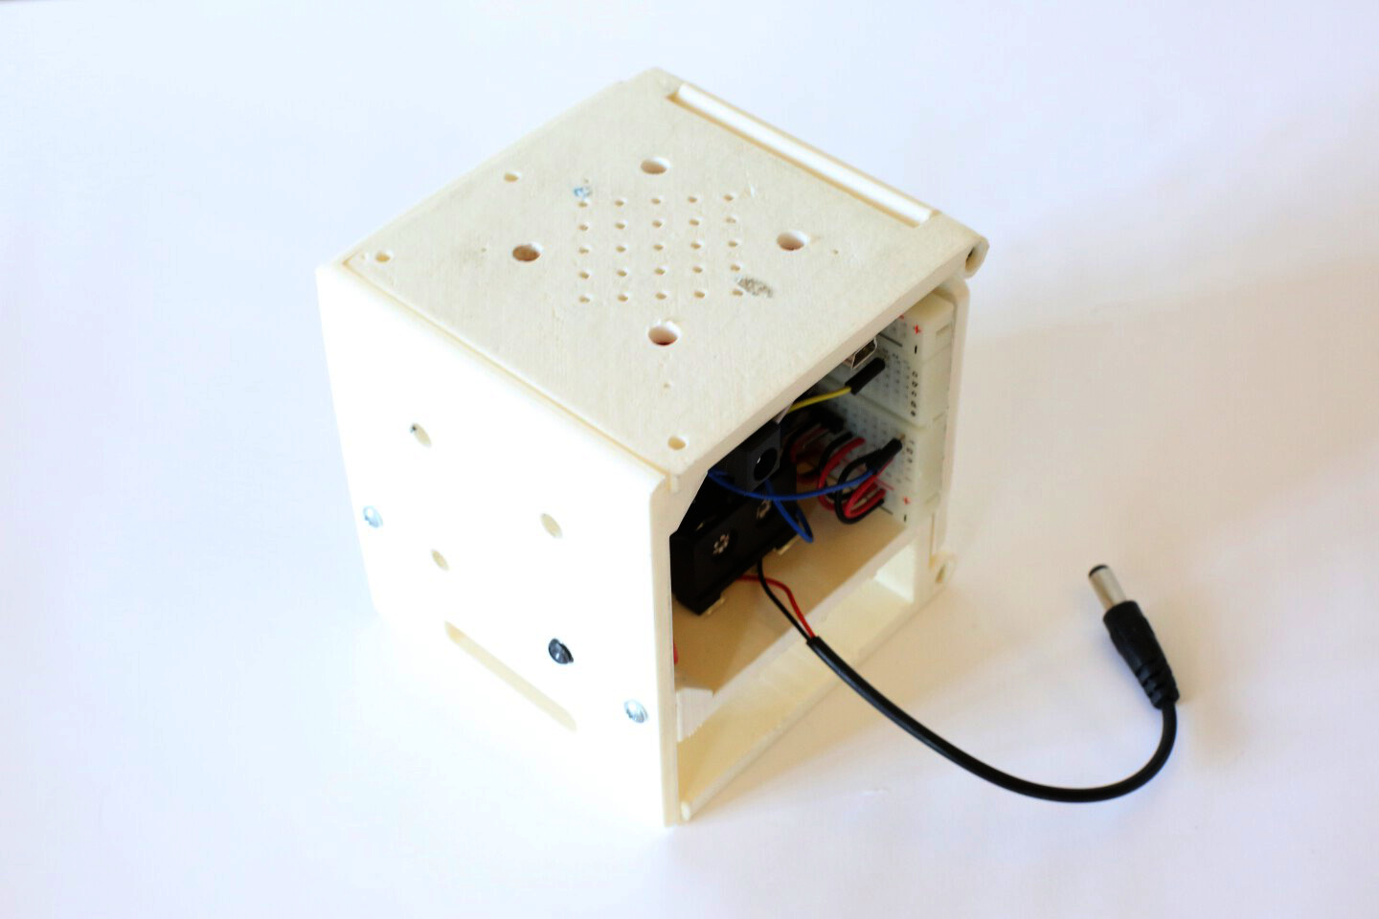Arduino Cube fully closed with three screws on top.
Googly Eye Double Mount
This is a playful attachment that gives the UR5 robot some personality with a set of two big googly eyes. A pair of screws on the far left and right sides holds the googly eyes together. This attachment comes in two pieces. In order to attach to the robot, the first piece must be screwed onto the UR5's front plate before screwing on the second piece.
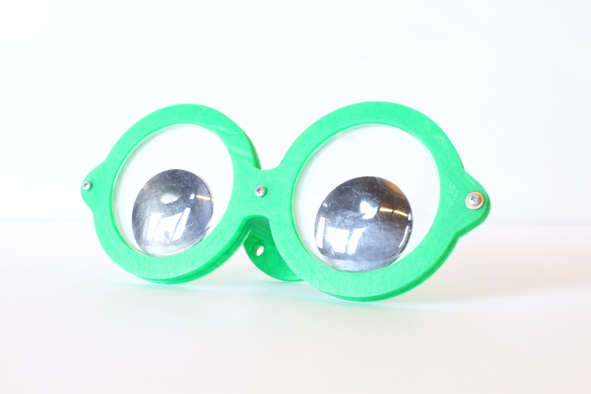Googly Eye Double Mount front.
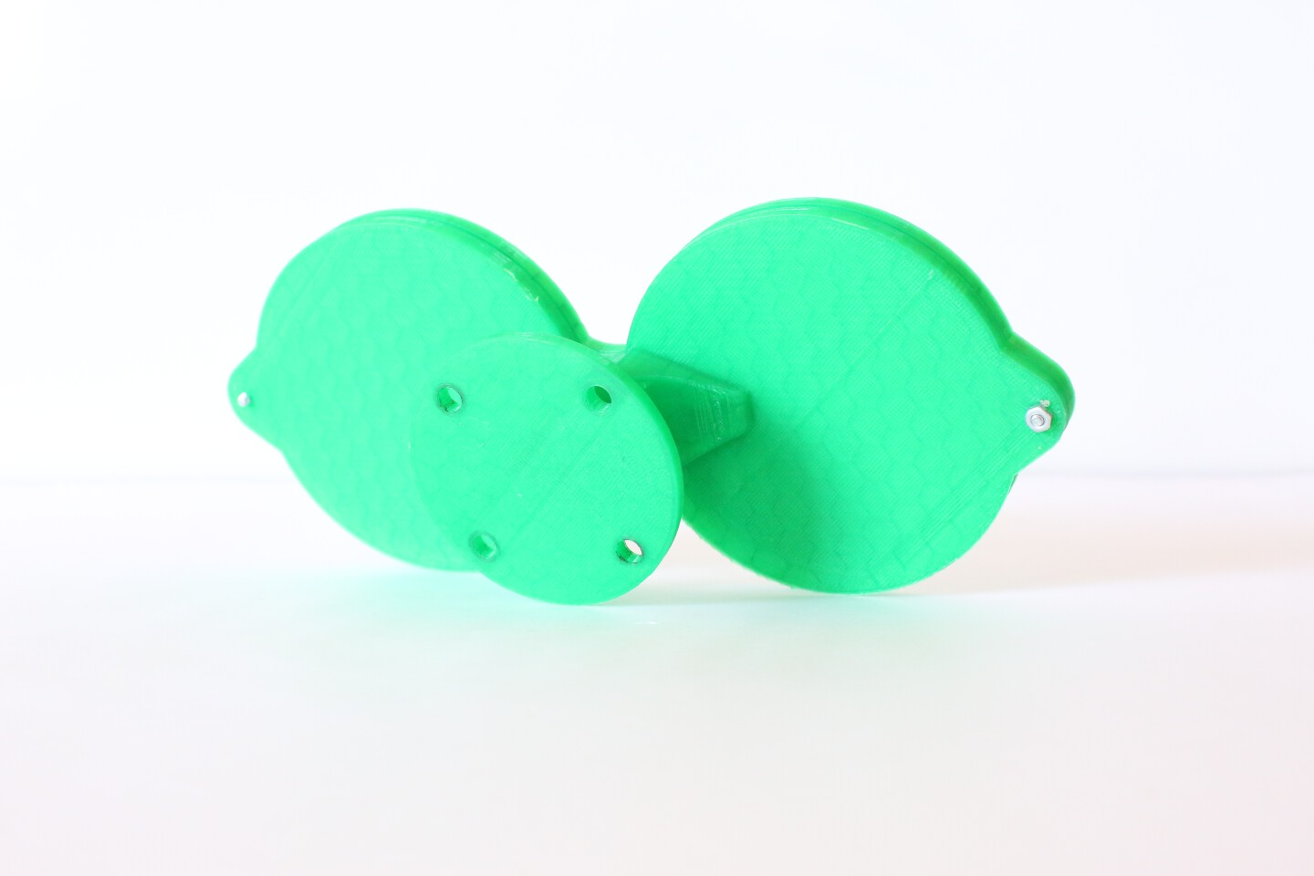Googly Eye Double Mount back.

Googly Eye Single Mount
This is the one-eyed variant of the Googly Eye Mount. A set of four screws on the upper and lower left and right tabs holds the Googly Eye together. Due to the large size of the Googly Eye, there are 6 components that need to be assembled together to form the attachment. Once assembled, this can be screwed directly onto the UR5's front base plate.
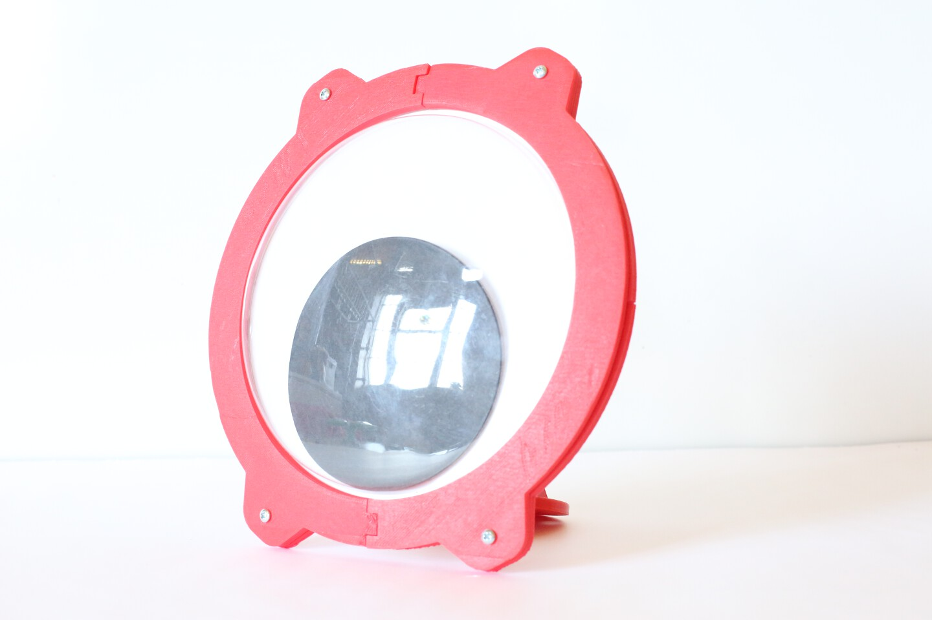Googly Eye Single Mount front.
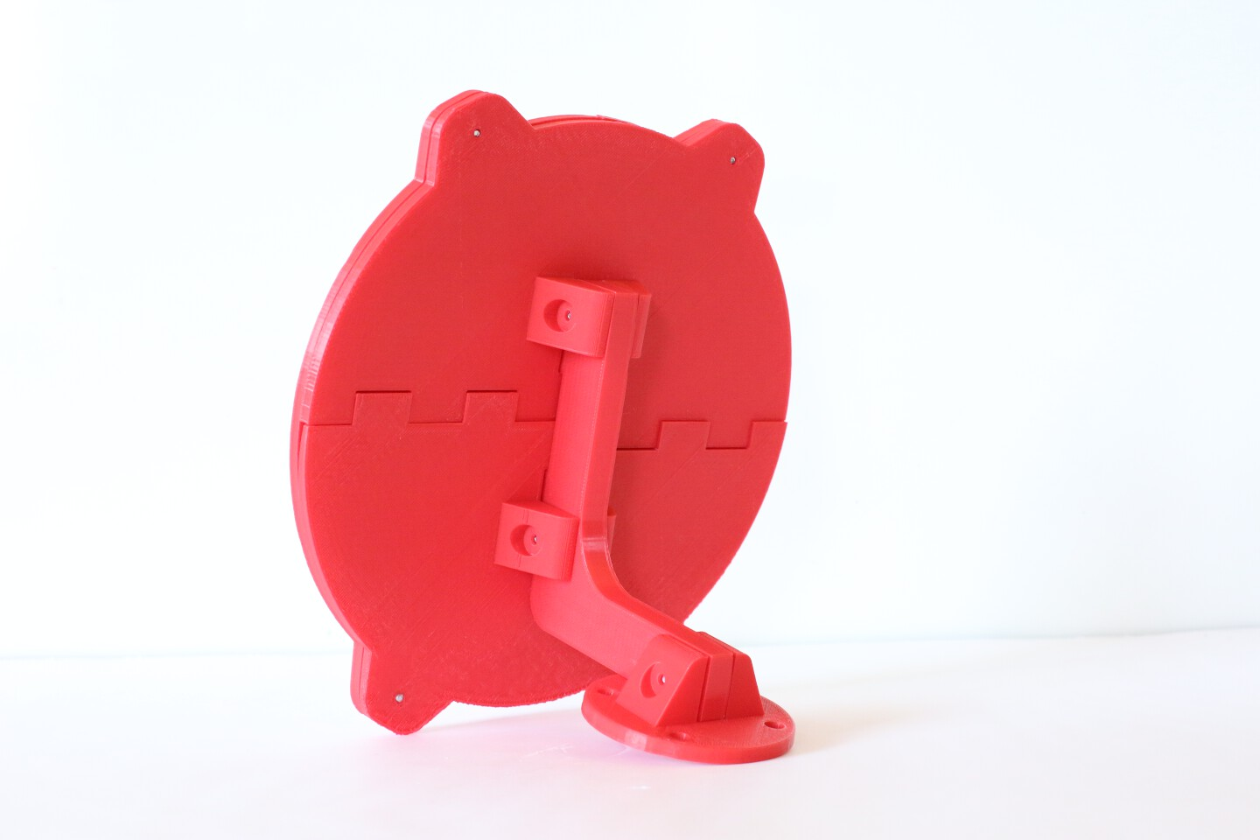Googly Eye Single Mount back.

Ryobi Caulk Gun Adapter
Custom-fabricated to enable Madeline Gannon's experimental "3D printing on the human body" research work, this device is built on top of a linear actuator extracted from a Ryobi Motorized Caulk Gun Extruder, adapted to dispense high-viscosity semi-solid clay material at various positions and orientations controlled by the UR5 robot arm. This attachment needs to be paired with the Breadboard mount and a 12 volt power source in order to work. To attach onto the robot, the Breadboard mount stacked with the first piece should be screwed onto the front plate of the robot with four M6x20 screws. Once this has been completed, the second piece (attached to the linear actuator and motor driver) can be screwed on with three M6x12 screws. While this attachment is fairly strong (five 4-40 screws hold the linear actuator in place), it is highly recommended to move the robot arm in a slow and predictable fashion while using this attachment.
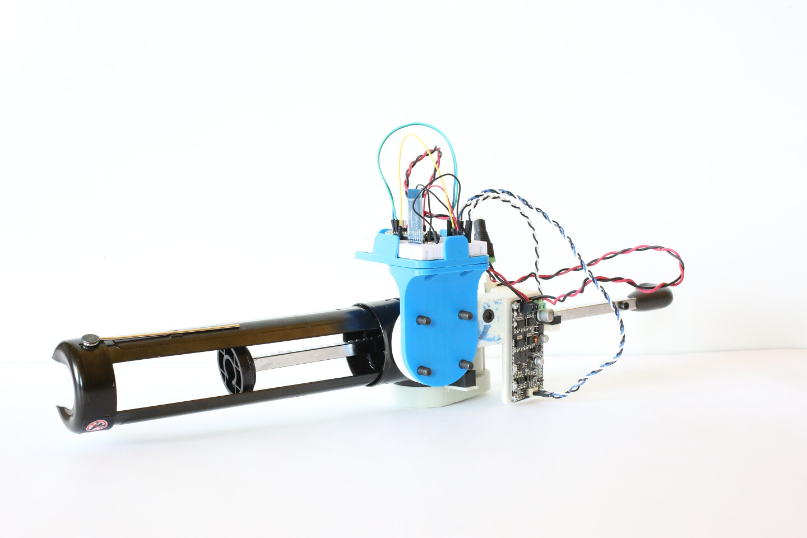Ryobi Caulk Gun Adapter, fully assembled with stacked Breadboard mount.
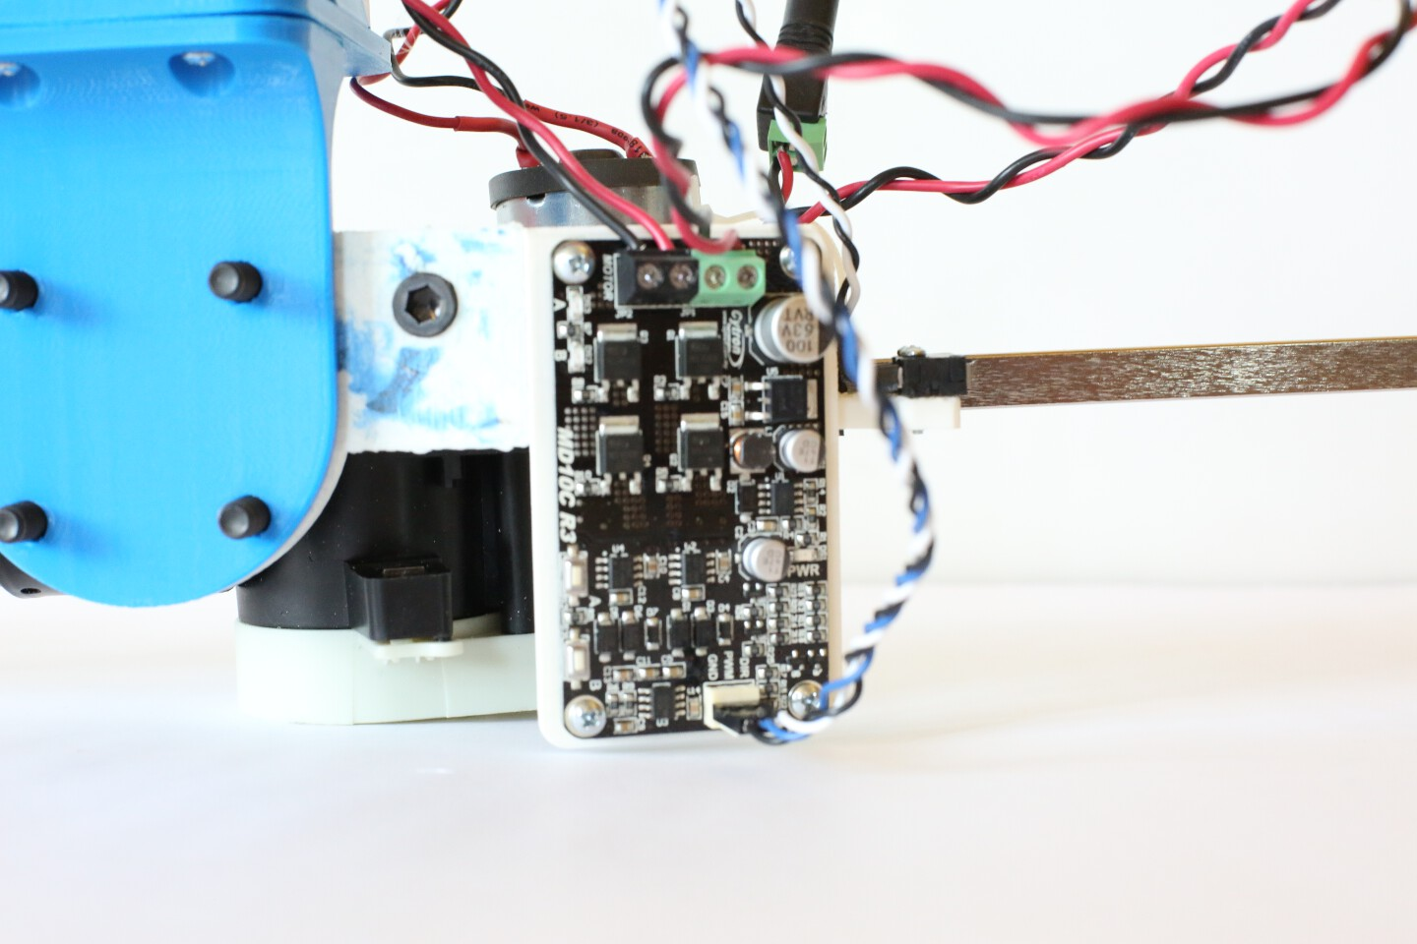Cytron Dual Motor Driver clearly visible with wires protruding.
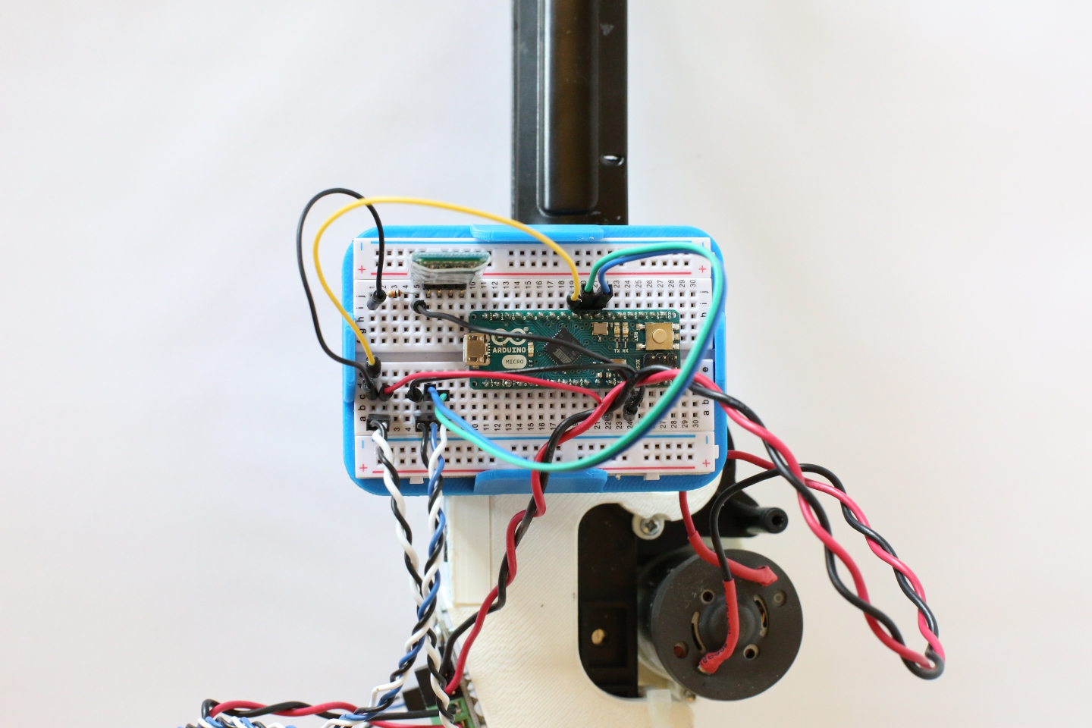Breadmount mount with Arduino Micro and HC-06 Bluetooth module for control.
Silly String Adapter
Built at Dan Moore's request, this attachment holds a canister of Silly String with a servomechanism to control the spray valve. The motor is a standard-size hobby servo that can be controlled by an Arduino. This attachment can be used in conjunction with the Breadboard mount. Note that this is a derivative of Thingiverse user sliptonic's Servo controlled Silly-String trigger:
http://www.thingiverse.com/thing:12256
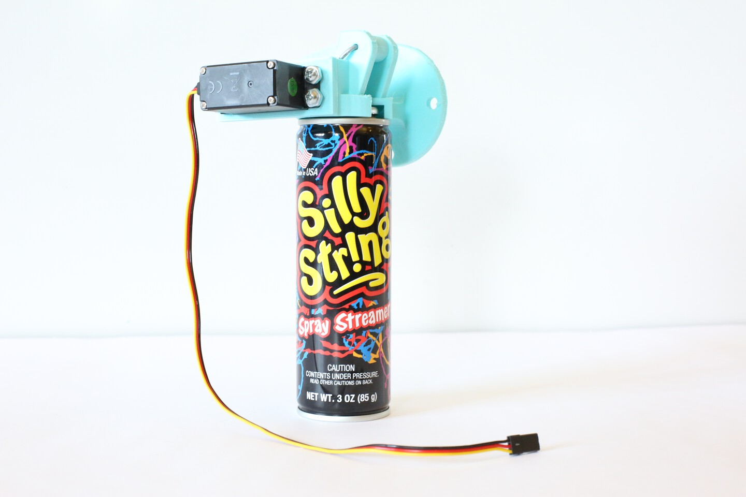Attachment with servomotor and Silly String canister attached.
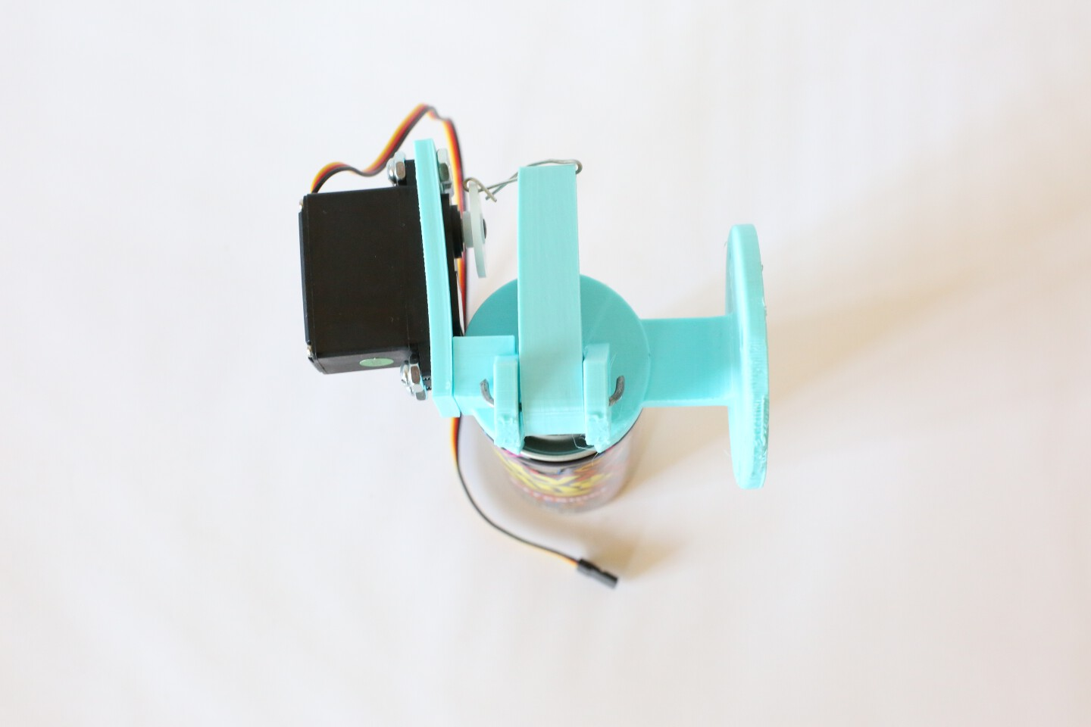Top view of the Silly String Adapter.

Tattoo Adapter
The STUDIO has recently acquired a tattoo etcher for artistic experiments in permanent body etching. Of particular interest was the ability to automate with the precision of a robotic arm. The Tattoo Adapter attachment fixes the tattoo etcher onto the UR5 robotic arm with a simple screw-on plate. As the robot arm is very powerful, it is advised to move it very slowly when in close proximity to humans.
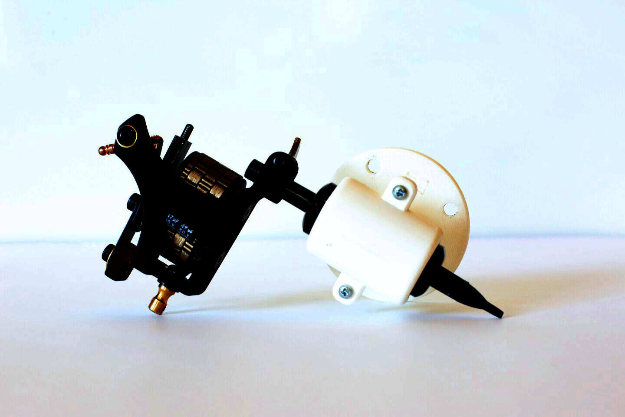Tattoo Adapter with etching device attached.
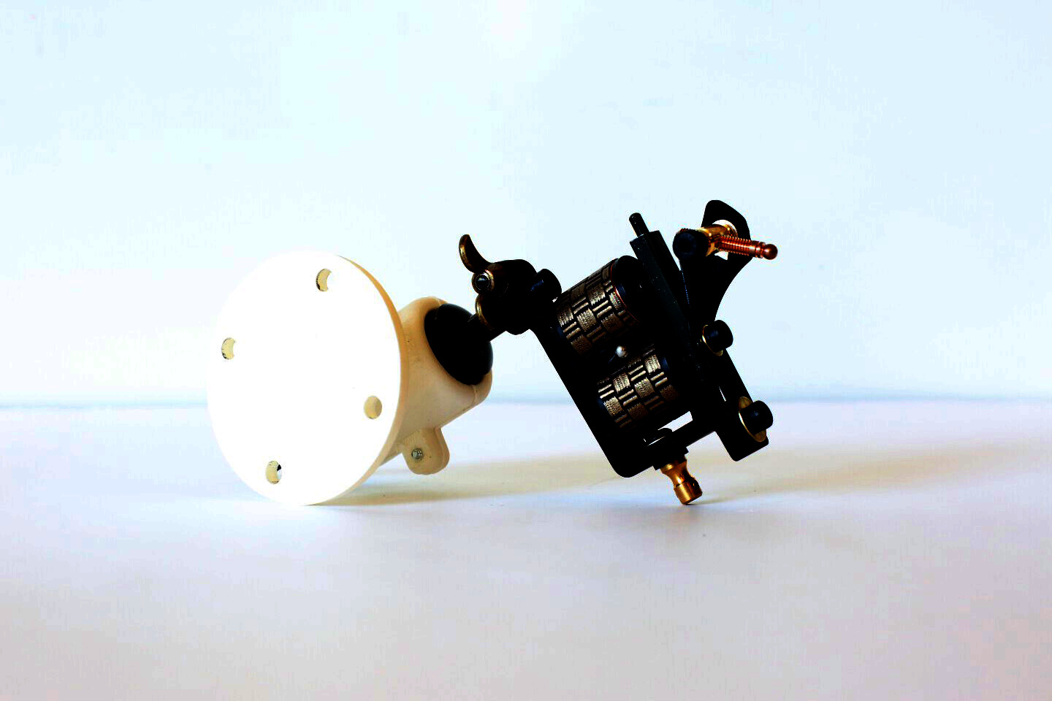Back view of Tattoo Adapter with etching device.

Threading Machine
Like the Ryobi Caulk Gun Adapter, the threading machine is another piece of custom hardware for use in Madeline Gannon's research. The threading machine is designed to rapidly wrap two threads of string around a human arm. As the arm passes through the hollow center of the device, the threading machine rapidly spins a large hollow gear with rolls of string around the arm, resulting in an arm covered in lots of string. Note that this is the second version of the design – gears work better than roller wheels.
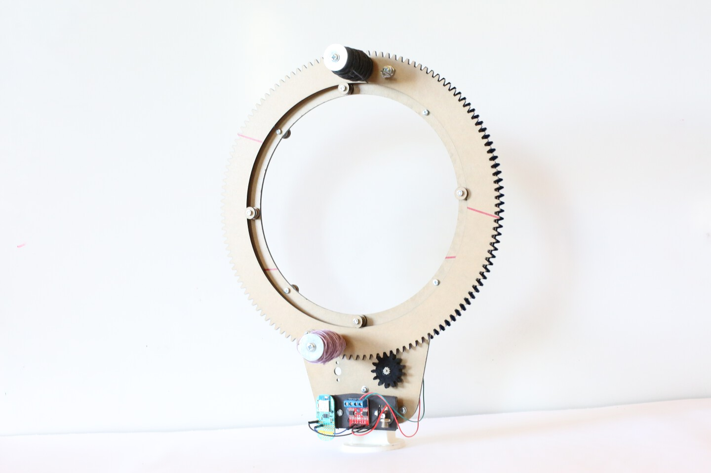Threading Machine, with gears and rolls of string clearly visible.
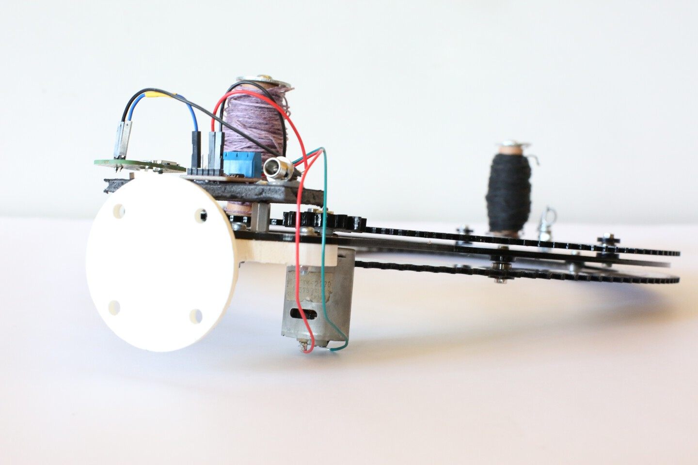Bottom view of threading machine with motors and electronics.

Gripper Mount
Since the beginning of robotic arms, the standard thing to attach to any robotic arm is a standard gripper. As such, a standard 3D-printable gripper was designed for use with the UR5 robot arm. High-torque metal geared servomotors give the gripper a lot of force, and it is expected to be able to hold roughly 1kg (2 water bottles) of mass. The best part: the Gripper Mount is a fraction of the cost of industry standard robotic grippers.
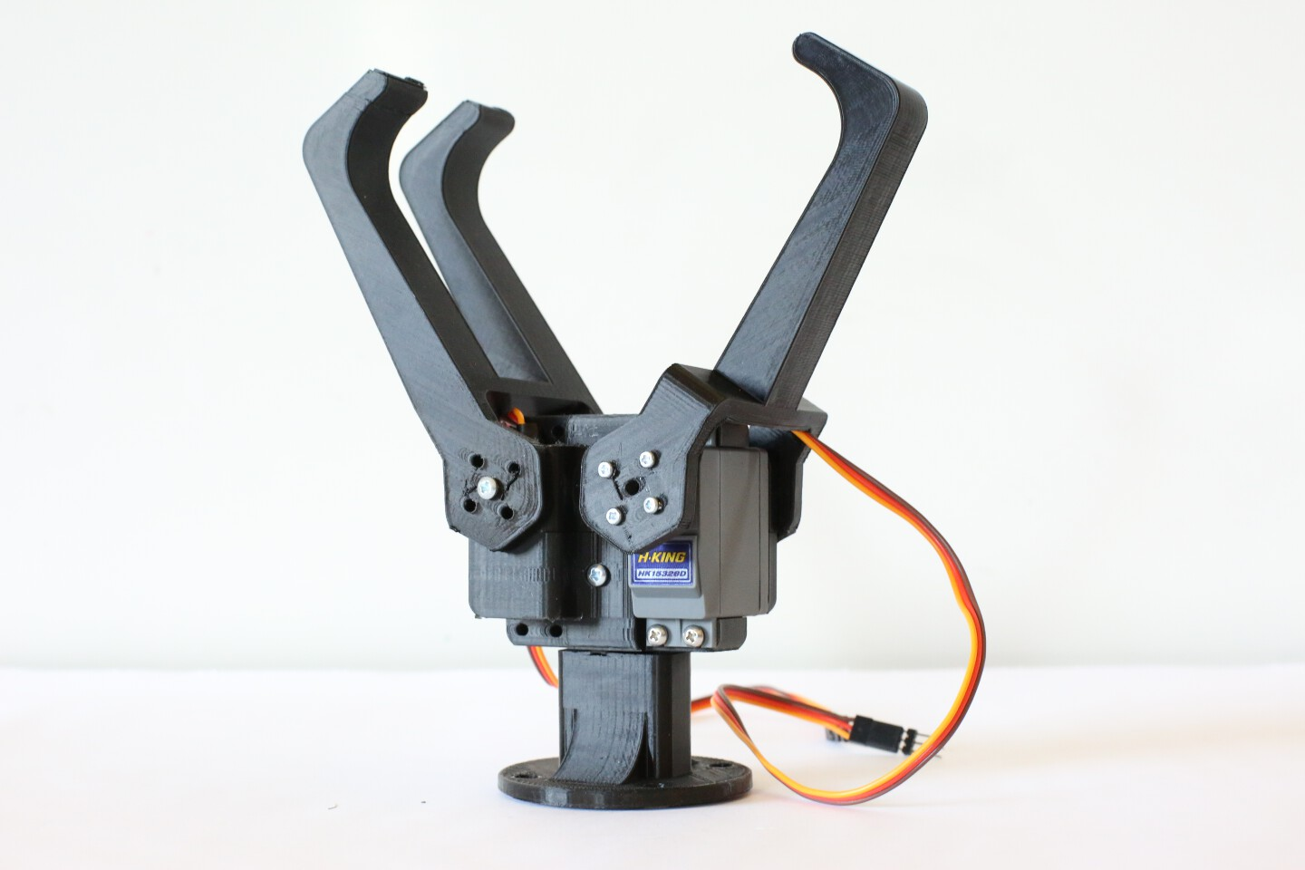Gripper Mount with claws open.
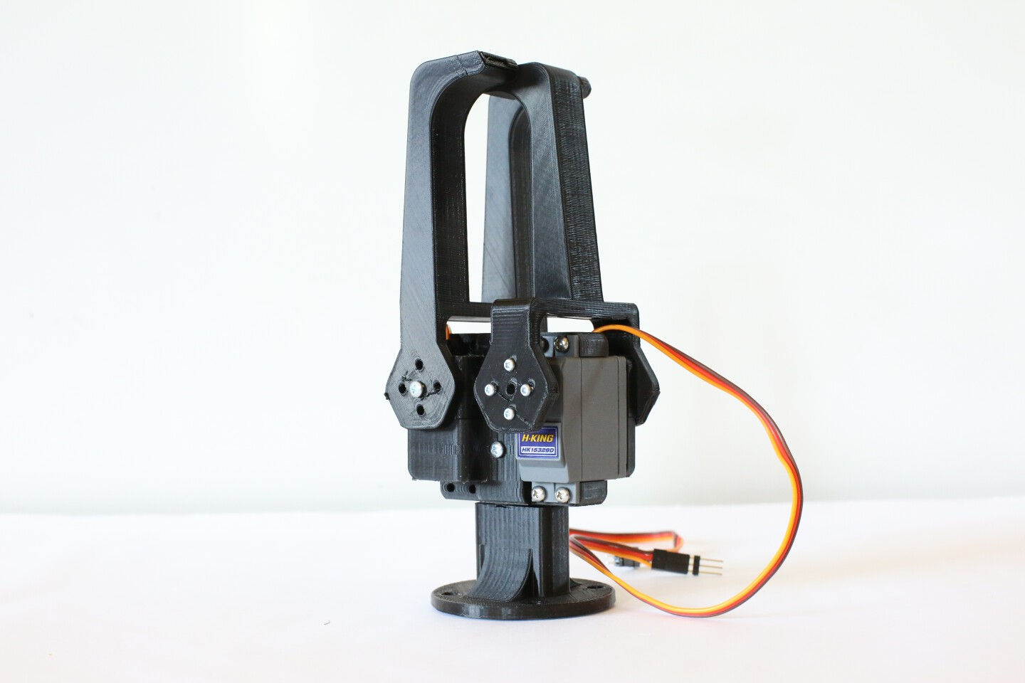Illustration 1: Gripper Mount with claws closed

CV Effector
This attachment is a triangular plate with three infrared identification spheres for use in computer vision applications. When used in conjunction with an infrared marker suit, this allows for creative human-robot interactions so that the robot knows exactly where the human is in relation to itself. Note that this attachment requires both a 3D-printed base mount and a laser-cut triangular plate in order to fabricate.
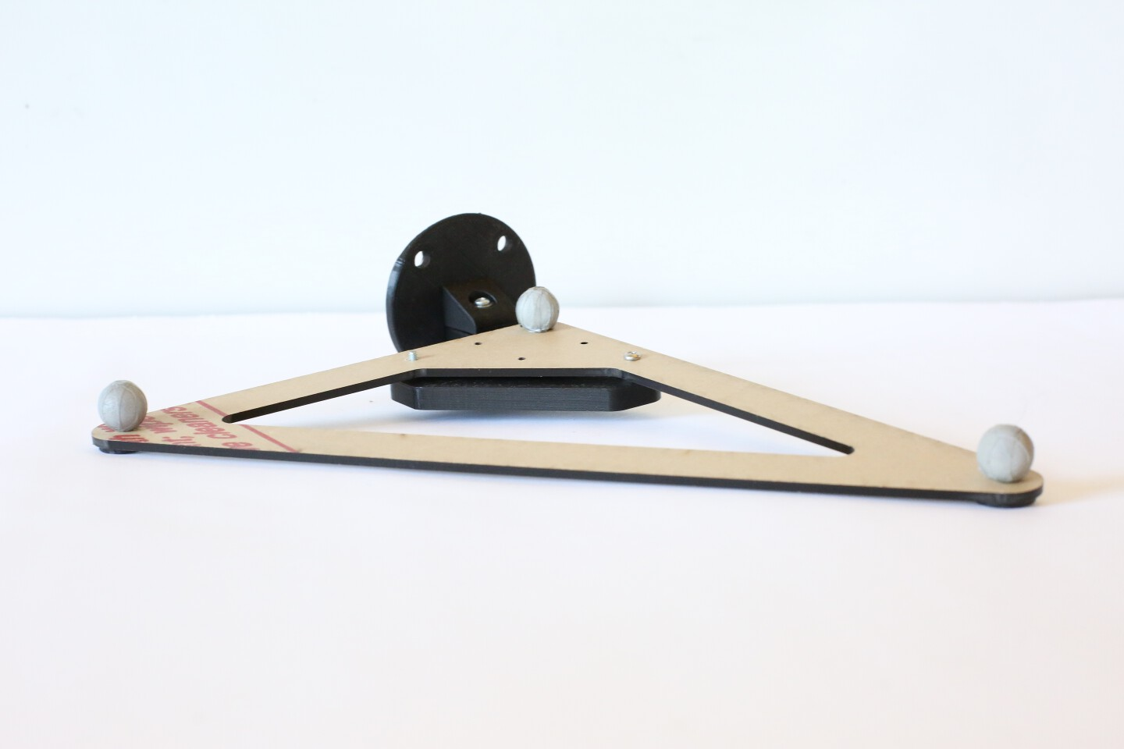CV Effector with 3 infrared identification spheres.

Finger Mount
Artificial human body part attachments allow the robot to literally become more human-like. An experiment in crossing the boundaries of the uncanny valley, the body part attachments are a twist on the common cyborg: instead of attaching robotic parts onto a human, we attach humanoid body parts onto a robot. The results are quite unsettling. The first of these attachments is the Finger Mount, allowing the robot to point at people.
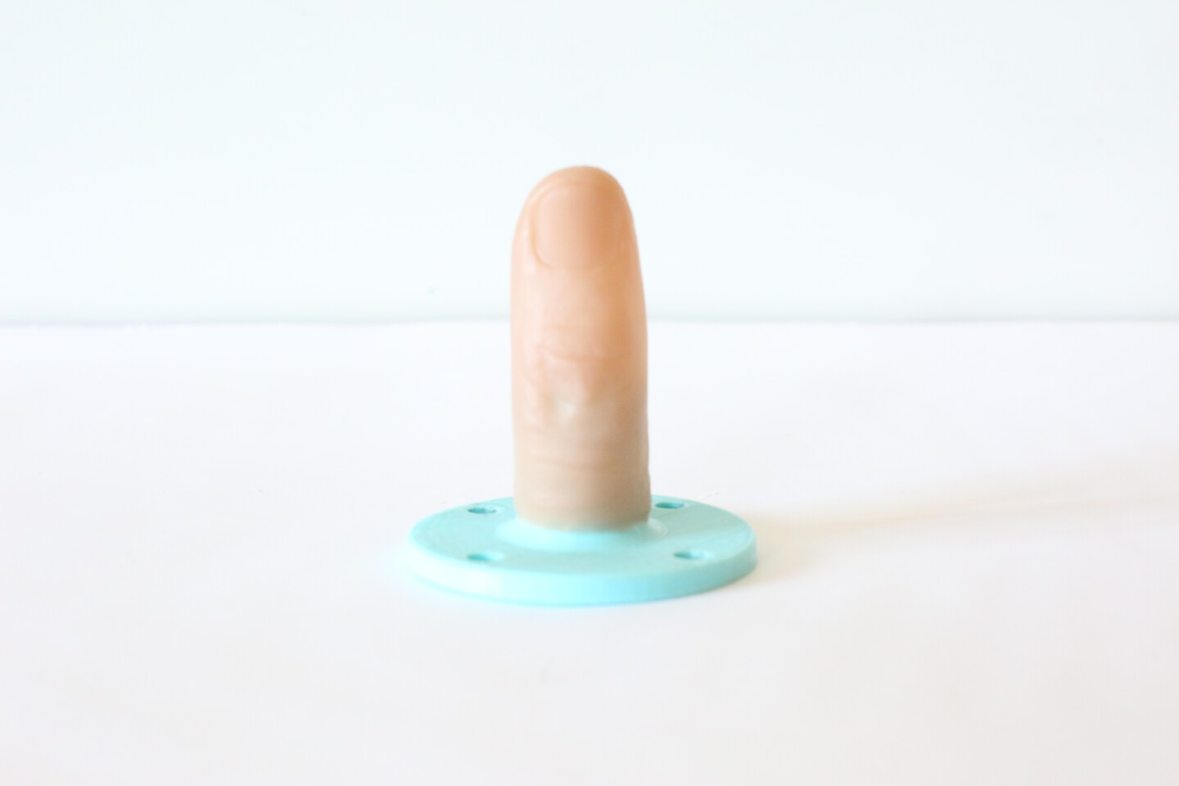Rubber finger attached to 3d printed mount with hot glue.

Hand Mount
The hand mount is the second body part attachment. It actually is a creative reuse of the universal Rod Adapter by Dan Moore, fastened to a rubber hand with generous amounts of superglue.
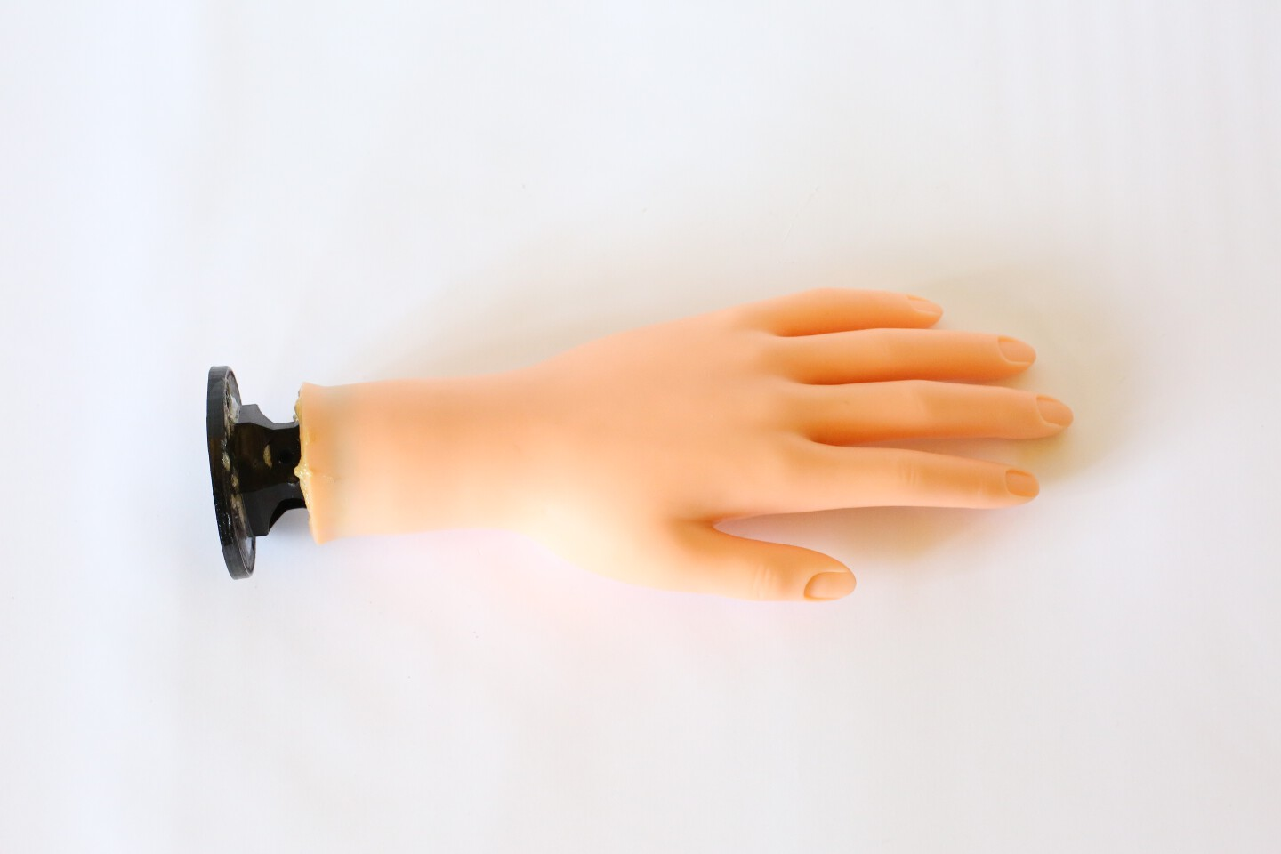Hand mount top view, placed flat on a surface.
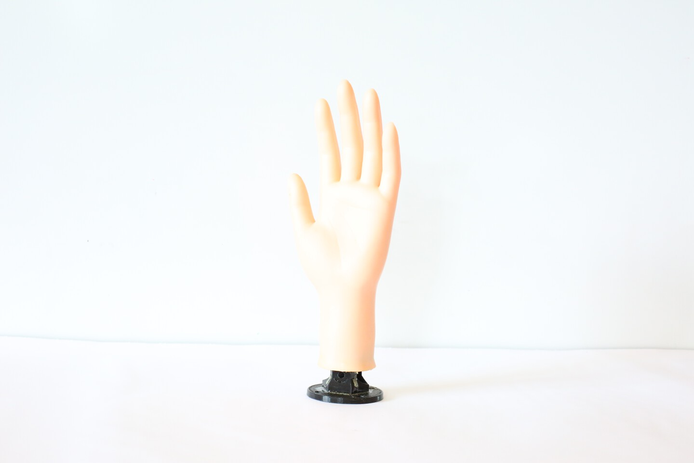Hand mount front view, placed vertically.

Head Mount
The third and last of the human-robot body part attachments is the Head Mount, and it is easily the most unsettling of the three. This attachment prints in two parts: the first piece is fixed to the back of the rubber head with three screws, and the second piece is fixed the to UR5 robot arm with four screws. The two pieces are joined together with two screws down the middle.
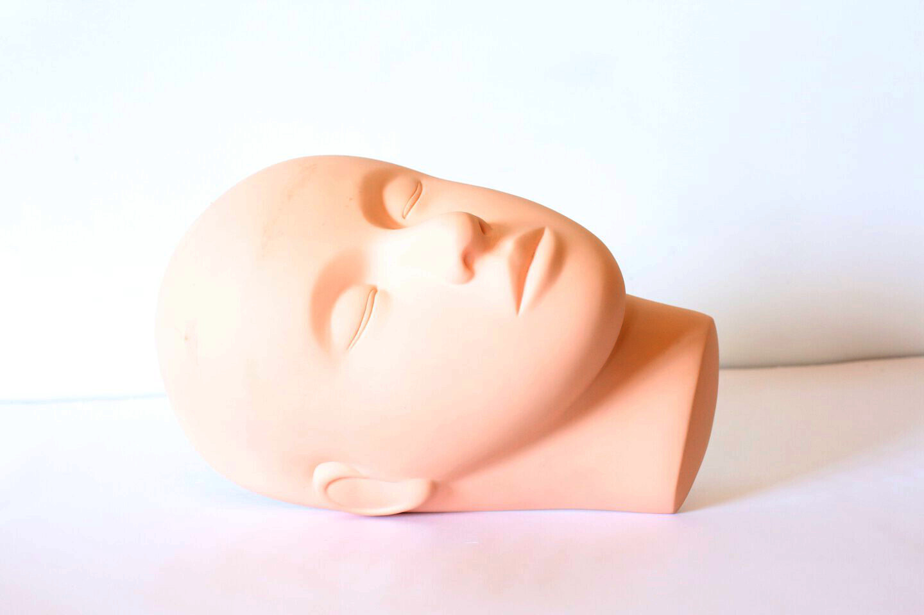Front view with only rubber head visible.
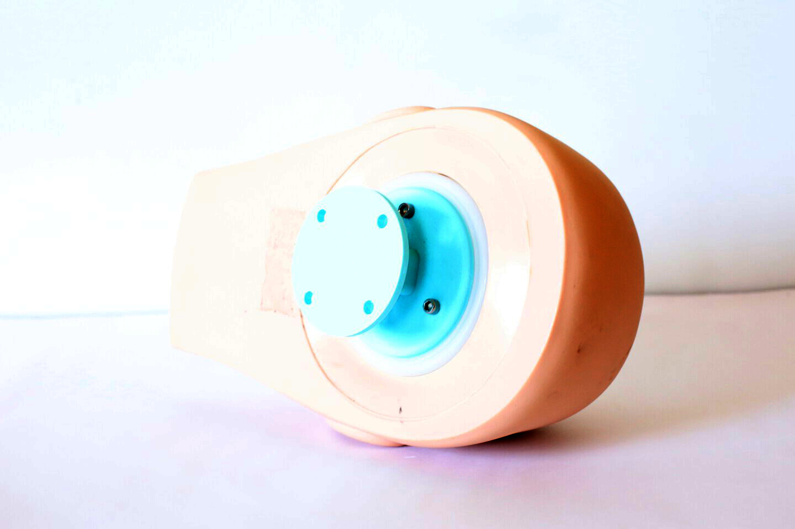Back view with 3D printed attachment visible.

